Algebra 3-4 Name: _____________________________
Factoring Worksheet Date: _________

Factor the expression. If the expression cannot be factored write not possible.

1. 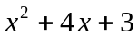 2. 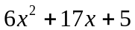 3. 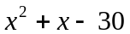 4. 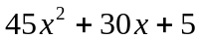

5. 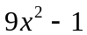 6. 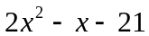 7. 8. 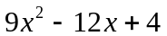

Simplify the expression.

9. 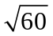 10. 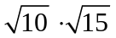

11. 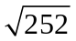 12. 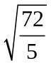

13. 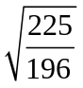 14. 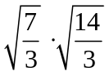

Solve the equation:

15. 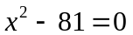 16. 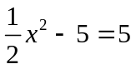 17. 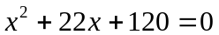

18. 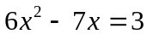 19. 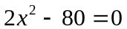 20. 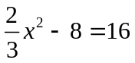

21. 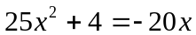 22. 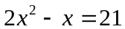 23. 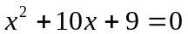

24. 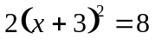 25. 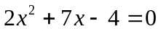 26. 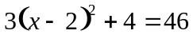

27. The area of a rectangle is 105 square units. The dimensions of the rectangle are x and 2x + 1. Find x.

